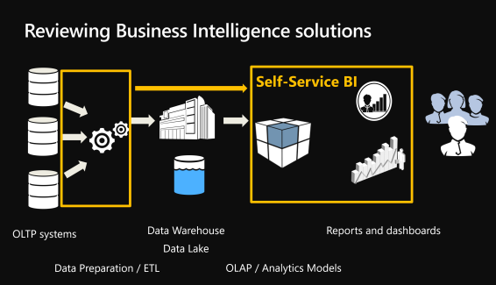

**OLTP OLAP**

INSERT SELECT  
UPDATE  
DELETE  
  
SELECT

**What is OLTP?**

An OLTP system captures and maintains transaction data in a database. Each transaction involves individual database records made up of multiple fields or columns. Examples include banking and credit card activity or retail checkout scanning.

In OLTP, the emphasis is on fast processing, because **OLTP databases are read, written, and updated frequently**. If a transaction fails, built-in system logic ensures data integrity.

**What is OLAP?**

OLAP **applies complex queries to large amounts of historical data, aggregated** from OLTP databases and other sources, for data mining, analytics, and **business intelligence** projects. In OLAP, the emphasis is on response time to these complex queries. Each query involves one or more columns of data aggregated from many rows. Examples include year-over-year financial performance or marketing lead generation trends. **OLAP databases and**[**data warehouses**](http://www.stitchdata.com/resources/data-warehouse/)**give analysts and decision-makers the ability to use custom reporting tools to turn data into information**. Query failure in OLAP does not interrupt or delay transaction processing for customers, but it can delay or impact the accuracy of business intelligence insights.

**ETL: the force that joins OLTP and OLAP**

The data from one or more OLTP databases is ingested into OLAP systems through a process called [**extract, transform, load (ETL)**](https://www.stitchdata.com/etldatabase/etl-process/). With an **ETL tool, users can collect data from several**[**sources**](https://www.stitchdata.com/integrations/sources/)**and send it to a**[**destination**](https://www.stitchdata.com/integrations/destinations/)**,** such as an OLAP data warehouse, where it is queried by [**analytics and business intelligence tools**](https://www.stitchdata.com/integrations/analysis-tools/) such as **EXCEL / POWER BI / SSAS** /**SSRS** for insights.

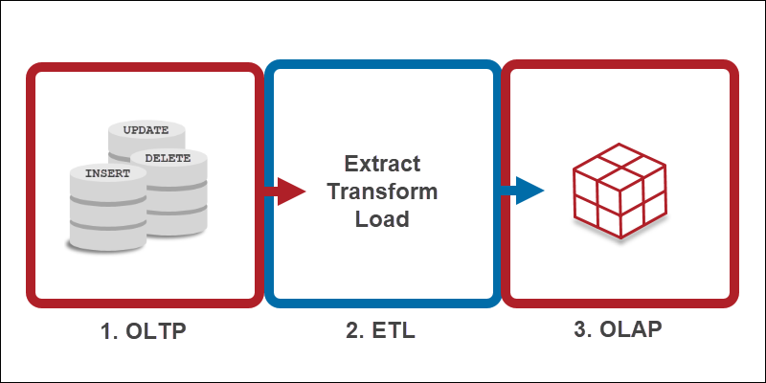

OLTP

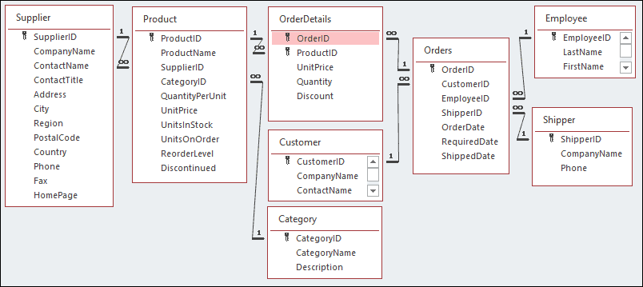

OLAP (Star Schema)

